- Modify Service Layer table allowlist configuration file.
- Go to <service layer installation folder>/conf/ folder. By default, it should be under folder “C:\Program Files\SAP\SAP Business One ServerTools\ServiceLayer\Conf\”
- Open b1s_sqltable.conf file.
- Add below table in the configuration file.
"OOAT",
"OAT1",
"ADM1",
"OCPR",
"PKL1",
"OPKL",
"PKL2",
"OINM",
"OITB",
"OSHP",
"OITL",
"ITL1",
"OWTQ",
"WTQ1",
"NNM1",
"OWGT",
"OWHS",
"OLCT",
"OSCN",
"WTR1",
"ITM9",
"OUOM",
"OBCD",
"OACT",
"NNM2",
"OUSR",
"ONNM",
"OSLP",
"OSPP",
"OSRI",
"@TRC_PARTNERDATA",
"@TRC_PARTNERCONFIG",
"CUDF"
- Restart the Services Layer Service by clicking on he Stop&Start button, by default the services page is available at https://localhost:40000/ServiceLayerController/ on the server
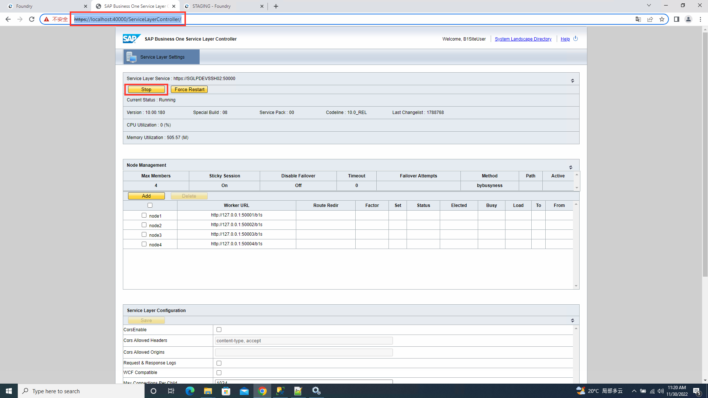
- BSP Change:
  - Add one config "Use Service Layer For SAP10 SQL". To use SL for SAP SQL, this option must be enabled.
<Parameter Name="UseServiceLayerForSQL" Description="Use Service Layer For SAP10 SQL" ControlType="4" Values="" MaxLength="0" SubCategory="50" />

